26.62: a) First do series/parallel reduction:
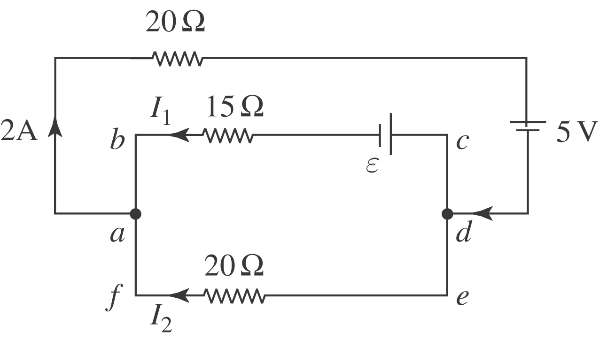
Now apply Kirchhoff’s laws and solve for
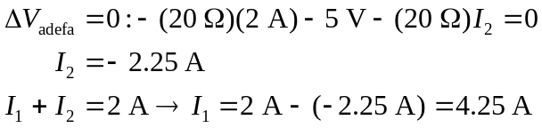
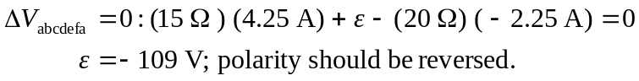
b) Parallel branch has a 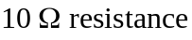.
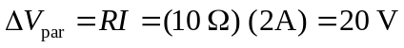
Current in upper part: 